Algorithm

Step 1: Create a maven project.

Step 2: Create TestNg File with name FlipkartLazyLoadingTest.

Step 3: Add necessary dependency like WebDriver, selenium, testng in pom.xml.

Step 4: Connect with Chromedriver.

Step 5: Take Flipkart website as target for automating web application. Step 6: Test all the features required for the solution.

Step 7: Try with different driver (I tried with edgedriver). Step 8: Check both driver rendering is same.

Chrome:

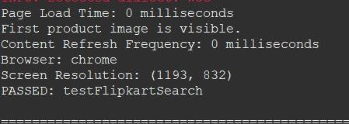

Edge:

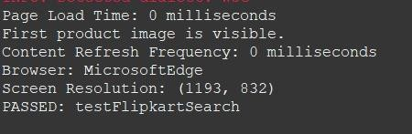

Step 9: Quit testng with quit () method